**EXPERIMENT-11**

**AIM:**

To create a compelling data story that explores the impact of Mid Day Meal Scheme (MDMS) launched in 1995.

**PROCEDURE:**

**Step 1:** Prepare this data sheet in MS-Excel.

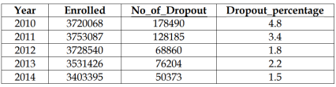

**Step 2:** Visualize the data using Line chart as

follows in Ms-Excel.

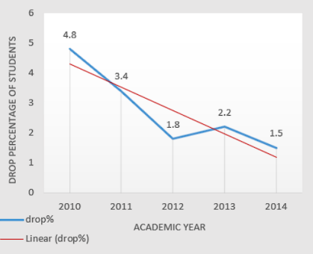

**Step 3:** Narrative:  
 Drop in percentage of students – a threat

**EXPERIMENT 12**

**AIM:**

To create a compelling data story that explores the impact of COVID vaccine.

**PROCEDURE:**

**Step 1:** Prepare this data sheet in MS-Excel.

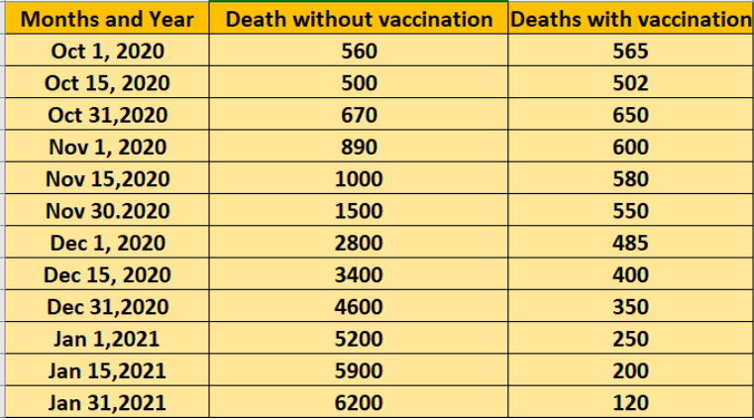

**Step 2:** Visualize the data using Line chart as

follows in Ms-Excel.

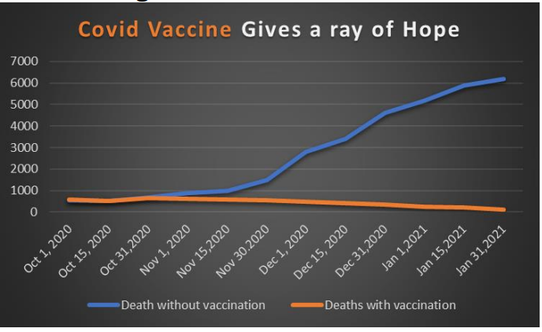

**Step 3:** Narrative:  
 Covid Vaccine- Gives a ray of Hope

| **E.No** | **TOPIC** | **Pg.No** |
| --- | --- | --- |
| 1 | Creation of a series from scalar values using pandas | 4 |
| 2 | Creation of data frame from numpy arrays | 6 |
| 3 | Creation of a data frame of given structure | 8 |
| 4 | Importing and exporting a data frame to a csv file | 10 |
| 5 | Displaying and checking the missing data in a data frame | 12 |
| 6 | Data visualization using orange data mining tool | 14 |
| 7 | Data Classification using orange data mining tool | 16 |
| 8 | Evaluating the classification model using orange data mining tool | 18 |
| 9 | Image analytics using orange data mining tool | 20 |
| 10 | Visualizing word frequencies with word cloud | 23 |
| 11 | Creation of a compelling data story that explores the impact of Mid Day Meal Scheme (MDMS) launched in 1995. | 25 |
| 12 | Creation of a compelling data story that explores the impact of COVID vaccine. | 27 |

**INDEX**